**Homework 3**

1. MW and M31 have similar mass of 2.06 10^12 Solar Mass. And the Halo is the most massive element with 1.975 for MW and 192.088 for M31.
2. The stellar mass of M31 is 1.6 time greater than MW. Therefore I expect M31 to be more Luminous since there is either more stars or more massive stars.
3. 1.975 10^12 Solar mass for MW and 1.921 10^12 Solar mass for M31, meaning that MW has 1.03 more Dark Matter. No because we know they have the same global mass so there must be more Dark matter in one and more stellar mass in the other.
4. 0.0412 for MW and 0.0675 for M31 so M31 is 1.6 time greater which represent their difference in stellar mass we saw in question 2).

Since the universe is expanding, assuming Dark Matter combine or something, we have less galaxies in a DM Halo now than during Early universe where galaxies where closer together (because of expansion). Therefore when looking at the universe, we see the past, when it was more Baryons contribution to the total mass.

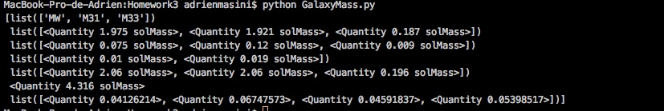

|  |  |  |  |  |  |  |
| --- | --- | --- | --- | --- | --- | --- |
| Galaxy name | Halo Mass (10^12) | Disk Mass (10^12) | Bulge Mass (10^12) | Total Mass (10^12) | Baryon Fraction (10^12) | |
| MW | 1.975 | 0.075 | 0.01 | 2.06 | 0.0413 | |
| M31 | 1.921 | 0.12 | 0.009 | 2.06 | 0.0675 | |
| M33 | 0.187 | 0.009 | / | 0.196 | 0.0459 | |
| Local Group | | / | / | / | 4.316 | 0.0540 |